Lab Report 2:

Implementing a Firewall with Load Sharing

Introduction
The purpose of this homework was to simulate a redundant firewall to compare performance of one versus multiple processors, and various queue sizes. The instructions requested algorithms to be tested assuming a single processor and multi-processor configurations of 1-2 processors, but my code is set up to work with even more if requested. The language used is Java (with threads) using semaphore logic to emulate an actual firewall implementation. As a reference, it is recommended to use the Barber semaphore. I used code named BoundedBuffer provided by Professor Lincke as a starting point for this project. In this paper I analyze some beautiful data using this code set to the standards requested by Professor Lincke during the test lab.

Method
One Java thread, pGen, acts as a client and is used to create and generate packets at a rate according to the sleep timer. Another thread, pProcessor, acts as a functioning firewall and is used to simulate the processing of the packets it accepts. Multiples of these threads can be used for different results. The amount of time it takes to process these packets is dictated by the service time, identified by ptime in my code. As packets are generated, they are fed into a buffer. The buffer contains a packet until it is chosen by the firewall to be processed. The number of packets the buffer can hold is dictated by the buffer limit. This limit can be exceeded if the code is set to take longer to process packets than it takes to generate them. If the buffer limit is exceeded, packets will then be dropped and added to a counter.

In Packet.java I calculate the average service times; turnaround times; and wait times, as well as the maximum values of the same variables. Using the counters in place, I also calculate the number of packets generated by my pGen thread, as well as the packets dropped by the buffer. Using these counters, I’m able to find the percentage of packets dropped, as well as the percentage of my processor’s utilization during the runtime. These values are displayed at the end of the runtime.

Results & Analysis
For my build, I’ll use what was requested in lab as a bassline. 1 generator; 1 processor; Buffer size = 5; service time = 12ms; arrival time = 10ms; runtime = 2min

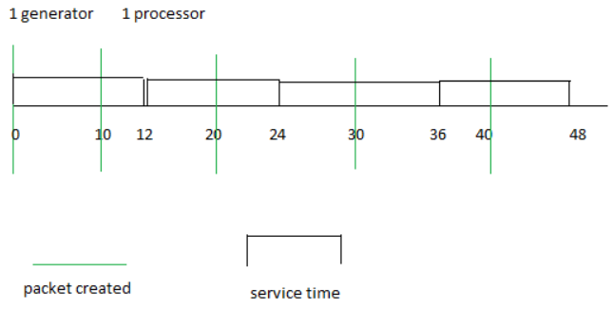
Packets created: 11281
Packets dropped: 1781
AVERAGE WAIT TIME: 57.28294532813652 ms.
MAXIMUM WAIT TIME: 72.0 ms.
AVERAGE TURNAROUND TIME: 69.9217318023807 ms.
MAXIMUM TURNAROUND TIME: 84.0 ms.
AVERAGE SERVICE TIME: 12.63878647424418 ms.
MAXIMUM SERVICE TIME: 17.0 ms.
PERCENTAGE PACKAGES DROPPED: 15.787607481606242%
PERCENTAGE PROCESSOR USAGE: 99.98250014583212%
Service time is the amount of time it takes for the firewall to process a packet. Turnaround time is total time taken between the submission of a packet for execution and the return of the packet. The wait time of a packet is its turnaround time – service time. % Packages dropped is equal to total packets dropped / total packets generated. % Processor utilization is total service time / run time.

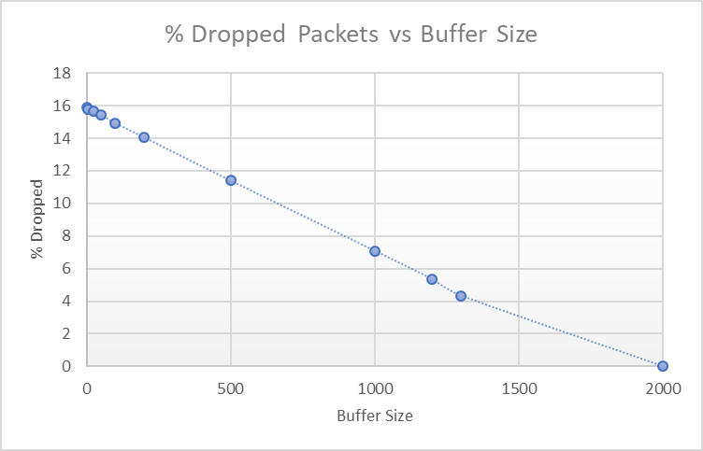
This graph represents the trend of the % of packets dropped through different buffer sizes. 1 generator; 1 processor; service time = 12ms; arrival time = 10ms; runtime = 2min. Analyzing the results tells us that the higher the buffer, the lower % dropped packets will be. This is because packets are stored in the buffer while waiting to be processed, similar to a queue. If a packet is in the queue, it can’t be dropped, resulting in this trend.

Cont.

2 generators; 1 processor; Buffer size = 5; service time = 12ms; arrival time = 10ms; runtime = 2min
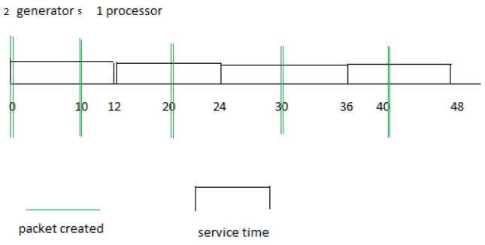
Packets created: 22584
Packets dropped: 13077
AVERAGE WAIT TIME: 57.53794337438164 ms.
MAXIMUM WAIT TIME: 67.0 ms.
AVERAGE TURNAROUND TIME: 70.16714030102095 ms.
MAXIMUM TURNAROUND TIME: 80.0 ms.
AVERAGE SERVICE TIME: 12.6291969266393 ms.
MAXIMUM SERVICE TIME: 19.0 ms.
PERCENTAGE PACKAGES DROPPED: 57.903825717322%
PERCENTAGE PROCESSOR USAGE: 99.99000016666389%
By adding a second generator without adjusting the buffer to compensate or adding another processor, you drastically increase the number of packets being generated at a time while only processing the same amount. In fact, you’ll notice that the number of packets generated was almost exactly double. In a perfect world, this number would be exactly double, as all I did was double the number of generators. The value most affected by this is, as expected, the amount of dropped packets and its %. This is because I increased the number of producers, but the rate of consumption stayed the same.

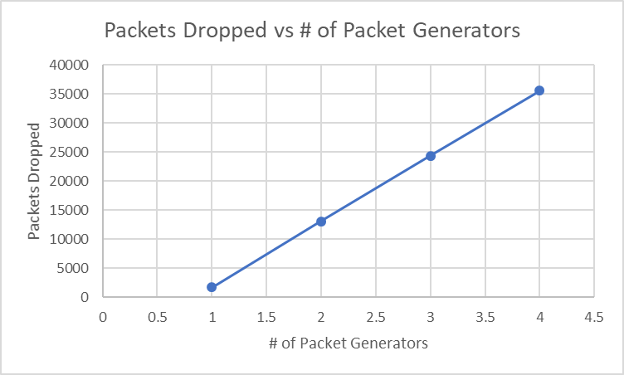
As you can see, my expected trend was correct. When adding packet generators with set times, the packets dropped with clime at an almost perfectly fixed rate. The reasoning for this is the same as what I said previously. As long at the timings are fixed, the ratio of generators to processors will go up statically, 1:1 2:1 3:1 4:1.

Cont.
1 generator; 2 processors; Buffer size = 5; service time = 12ms; arrival time = 10ms; runtime = 2min
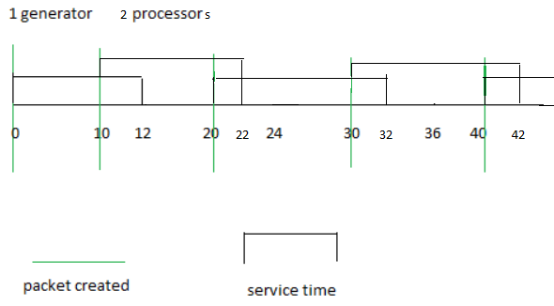
Packets created: 11316
Packets dropped: 0
AVERAGE WAIT TIME: 7.070885628424961E-4 ms.
MAXIMUM WAIT TIME: 3.0 ms.
AVERAGE TURNAROUND TIME: 12.632313947321903 ms.
MAXIMUM TURNAROUND TIME: 18.0 ms.
AVERAGE SERVICE TIME: 12.63160685875906 ms.
MAXIMUM SERVICE TIME: 18.0 ms.
PERCENTAGE PACKAGES DROPPED: 0.0%
PERCENTAGE PROCESSOR USAGE: 119.09003791508688%
Here we can see that the same ratios exist when using only one generator and multiple processors. However, the numbers go in the other direction. Additionally, you can see from my prediction drawing that once again the average times are just about spot on.

1 generator; 1 processors; Buffer size = 5; service time = random ms; arrival time = random ms; avg service time = 5; runtime = 2min
Packets created: 23666
Packets dropped: 4409
AVERAGE WAIT TIME: 21.524670198400333 ms.
MAXIMUM WAIT TIME: 56.0 ms.
AVERAGE TURNAROUND TIME: 27.7040095564558 ms.
MAXIMUM TURNAROUND TIME: 63.0 ms.
AVERAGE SERVICE TIME: 6.179339358055469 ms.
MAXIMUM SERVICE TIME: 13.0 ms.
PERCENTAGE PACKAGES DROPPED: 18.63010225640159%
PERCENTAGE PROCESSOR USAGE: 99.14667377771852%
You’ll notice the maximum wait time and maximum turnaround time are both significantly higher than the manually entered stats. This is due to the randomized times. It’s because of these randomized outliers that the averages for these times are also brought higher.

Aside from a millisecond or 2 from program startup or the fact I always have a million programs running on my computer, the manually-generated statistics were pretty much spot on. Another reason for the millisecond off could also be my output. I generate a lot of output so that I can look back and make sure everything is running properly, and that probably affected timing a bit. With regards to the barbershop logic stimulating my logic, it absolutely did. I would not have understood the code without understanding the barbershop concept and it is how I wrote the code.
Using nonrandom times makes everything relatively consistent and predictable, while random was the opposite, obviously. With regards to how the code runs, not much changed, but when using random times one thing I noticed were the drastic changes in turnaround and wait times. The average and max were usually very different between simulations due to the random outliers. Additionally, I noticed that the longer you ran the simulation, the closer it would get to the chosen average for service time.

Conclusion
This turned out to be one of my favorite projects since coming to Parkside. I felt like I was able to take knowledge I’ve gained from other classes like networking and see the process in action. Not only that, but I could bend it to my will and gain an even better understanding of how it works. The most important thing I learned was probably about semaphores and how they can affect your code. The project demonstrated further how threads work conceptually and how multiple threads can interact with each other. All in all, the takeaway from this lab, I feel, was a combined educational experience from the entire semester so far, from static variables, to threads, and all the way to semaphores.

